Vogue 170

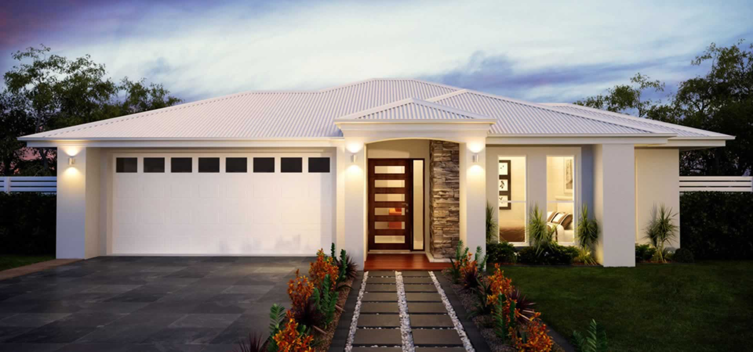

Classic 1 Platinum

luxury inclusions
- Generous Entrance Foyer
- Open plan Kitchen / Dining / Living
- Zoned living & sleeping
- Bed 2 or Study option
- Built-in robes to Beds 2, 3 & 4
- WIR and Ensuite to Master
- Outdoor Alfresco living
- Optional Outdoor Living
- Optional Outdoor Kitchen
- Double Garage with internal access
- Extensive range of facades available

additional information
Floor Area (m2) | 170
Bedrooms | 4
Bathrooms | 2
Garage Spaces | 2
Living Rooms | 1
Min. Site Width (m) | 16

